End-to-End CI/CD Pipeline on AWS Using Bamboo, Docker, GitHub, and EC2
Introduction:
In this project, we built a complete End-to-End CI/CD Pipeline on AWS using Bamboo as the core automation tool. The pipeline takes source code from GitHub, builds the application, creates a Docker image, and finally pushes it to DockerHub.
Virtual Private Cloud (VPC):
A VPC (Virtual Private Cloud) is your own private network inside AWS.It lets you control IP ranges, subnets, route tables, and how your resources (EC2, RDS, etc.) communicate securely.
Steps:
Go to VPC Dashboard → Create VPC
Choose IPv4 CIDR (example: 10.0.0.0/16)
Create Public Subnet
Create Internet Gateway (IGW) and attach it to the VPC
Update Route Table for public subnet → add route 0.0.0.0/0 via IGW
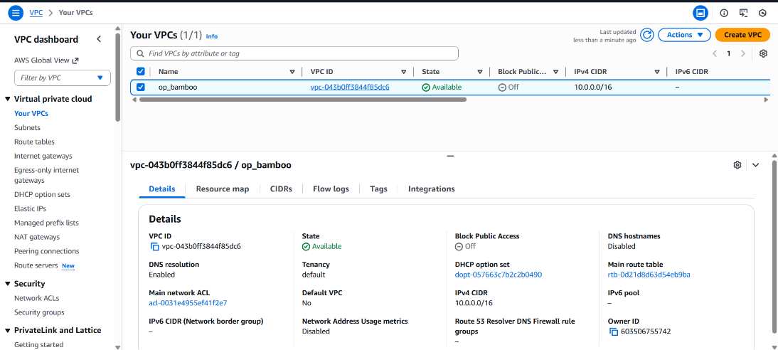

EC2 Instance (Ubuntu Server):
An EC2 instance is a virtual machine in AWS where we deploy and run our application and CI/CD tools.
Steps:
Go to EC2 Dashboard → Launch Instance
Select Ubuntu 22.04 LTS AMI
Choose instance type t2.xlarge
Select the VPC and Public Subnet created earlier
Enable Auto-assign Public IP
Create or select a Key Pair
In Security Group, allow
SSH → port 22
HTTP → port 80
Custom port for Jenkins (if used) →8080
Custom port for bamboo (if used) →8085
Custom tcp port →54663
Launch the instance:
Connect using SSH:
ssh -i yourkey.pem ubuntu@52.66.194.253
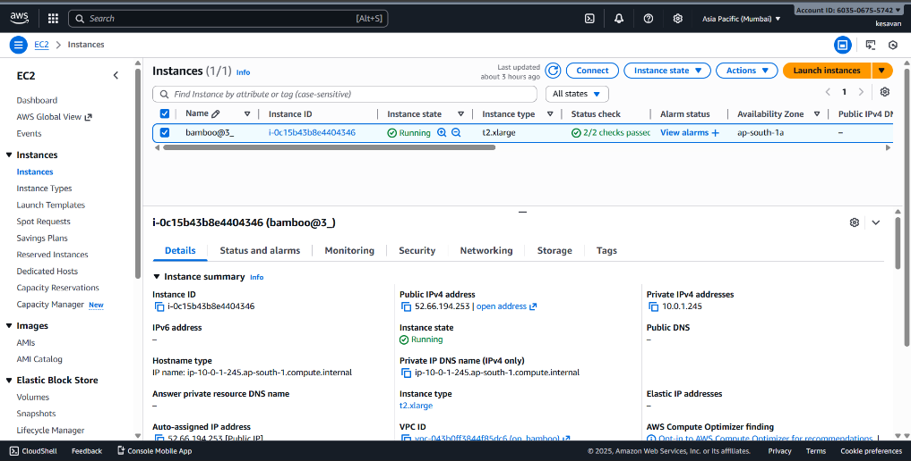
Git & GitHub Setup:
Git is a version-control tool, and GitHub is a cloud platform where we store our project’s source code and Jenkins pipeline file.
Steps:
Install Git on EC2:
sudo apt update
sudo apt install git -y
Configure Git:
git config --global user.name "virakesavan"
git config --global user.email "virakesavan@gmail.com"
Create a GitHub repository:
Repository Name: hello-vira-nodejs
Username: virakesavan
Clone the repo to EC2:
git clone https://github.com/virakesavan/hello-vira-nodejs.git
Added project files + Jenkinsfile into the repo
Pushed updates to GitHub:
git add .
git commit -m "project setup with Jenkinsfile"
git push origin main
Apache Setup:
Apache is a web server used to host applications or static pages.
Steps:
Installed Apache:
sudo apt install apache2 -y
Checked service status:
systemctl status apache2
Verified in browser using:
http:// 52.66.194.253
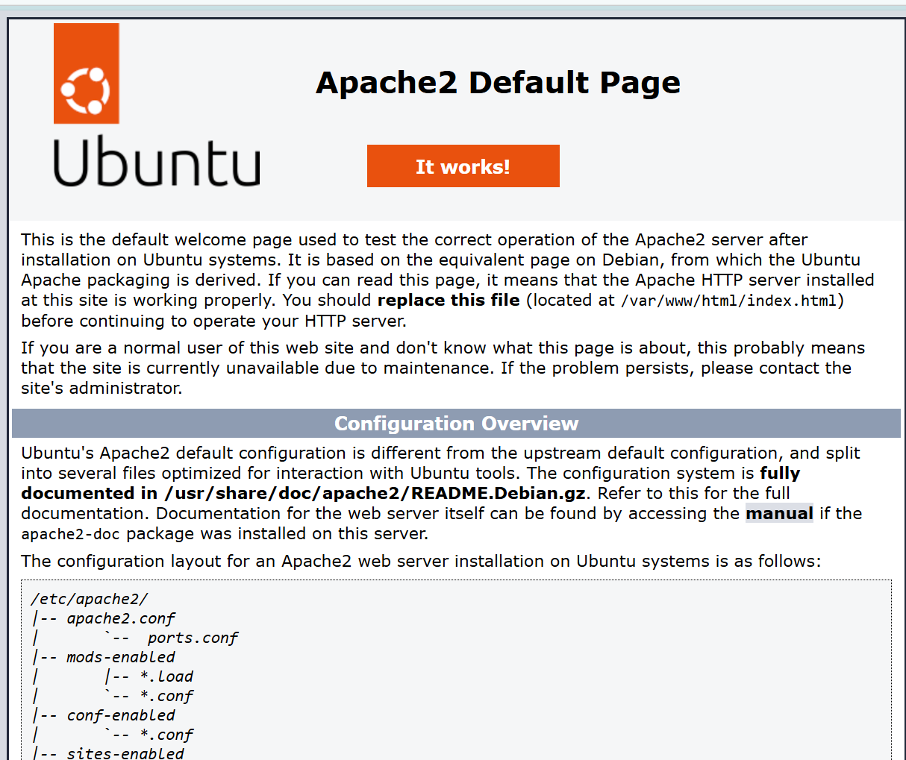
Docker (Containerization Tool):
Docker is a platform that packages applications into lightweight, portable containers.It helps run the same application on any system without compatibility issues.
Steps to Install Docker on Ubuntu EC2:
Update system packages
sudo apt update -y
sudo apt upgrade -y
Install required dependencies
sudo apt install apt-transport-https ca-certificates curl software-properties-common -y
Add Docker’s official GPG key
curl -fsSL https://download.docker.com/linux/ubuntu/gpg | sudo apt-key add -
Add Docker repository
sudo add-apt-repository "deb [arch=amd64] https://download.docker.com/linux/ubuntu focal stable”
Install Docker Engine
sudo apt update -y
sudo apt install docker-ce docker-ce-cli containerd.io -y
Check Docker version
docker –version
Add current user (ubuntu) to Docker group
sudo usermod -aG docker ubuntu
Restart Docker
sudo systemctl restart docker
DockerHub (Container Registry):
DockerHub is an online repository where we store and share Docker images.In this project, DockerHub is used to push the built image so Bamboo can pull and deploy it.
Steps: Configure DockerHub
Go to DockerHub website
https://hub.docker.com
Create a Repository
Click Create Repository
Repository Name → hello-vira-nodejs
Visibility → Public
Description → “Docker image for CI/CD project using Bamboo”
Docker login
Username → virakesavanvetrivel
Password → **********
Verify login
docker info
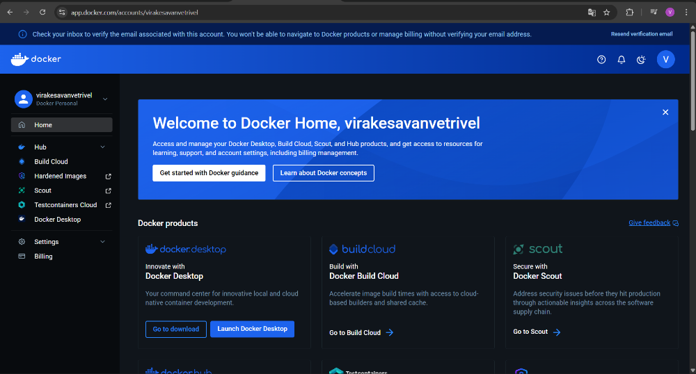
Jenkins (CI Server):
Jenkins is an automation server used to pull code from GitHub, install dependencies, build the Docker image, and push it to DockerHub.
Steps: Install & Configure Jenkins on Ubuntu EC2
Install Java (required for Jenkins)
sudo apt update
sudo apt install openjdk-17-jdk -y
Add Jenkins repository
Install Jenkins
sudo apt update
sudo apt install jenkins -y
Start & Enable Jenkins
sudo systemctl start Jenkins
sudo systemctl enable jenkin.
Access Jenkins
Open browser → http:// 52.66.194.253:8080
Enter initial admin password
sudo cat /var/lib/jenkins/secrets/initialAdminPassword
Jenkins & Bamboo Integration:
Jenkins automates the build process, while Bamboo is the main CI/CD tool that coordinates the pipeline from GitHub to deployment.
Steps :
Install Jenkins on EC2 and start the service.
Configure Jenkins credentials (GitHub username virakesvan and personal access token).
Connect Jenkins with Bamboo by setting up a plan in Bamboo that triggers Jenkins jobs.
Verify Jenkins successfully builds the project whenever Bamboo triggers a pipeline run.
Bamboo (CI/CD Tool):
Bamboo is an automated CI/CD tool by Atlassian that helps to build, test, and deploy applications. It connects with GitHub to pull the latest code, builds it, and triggers deployment pipelines automatically.
Download & Install Bamboo
Install Bamboo on your server (Windows/Linux based on your screenshots).
Start the Bamboo service.
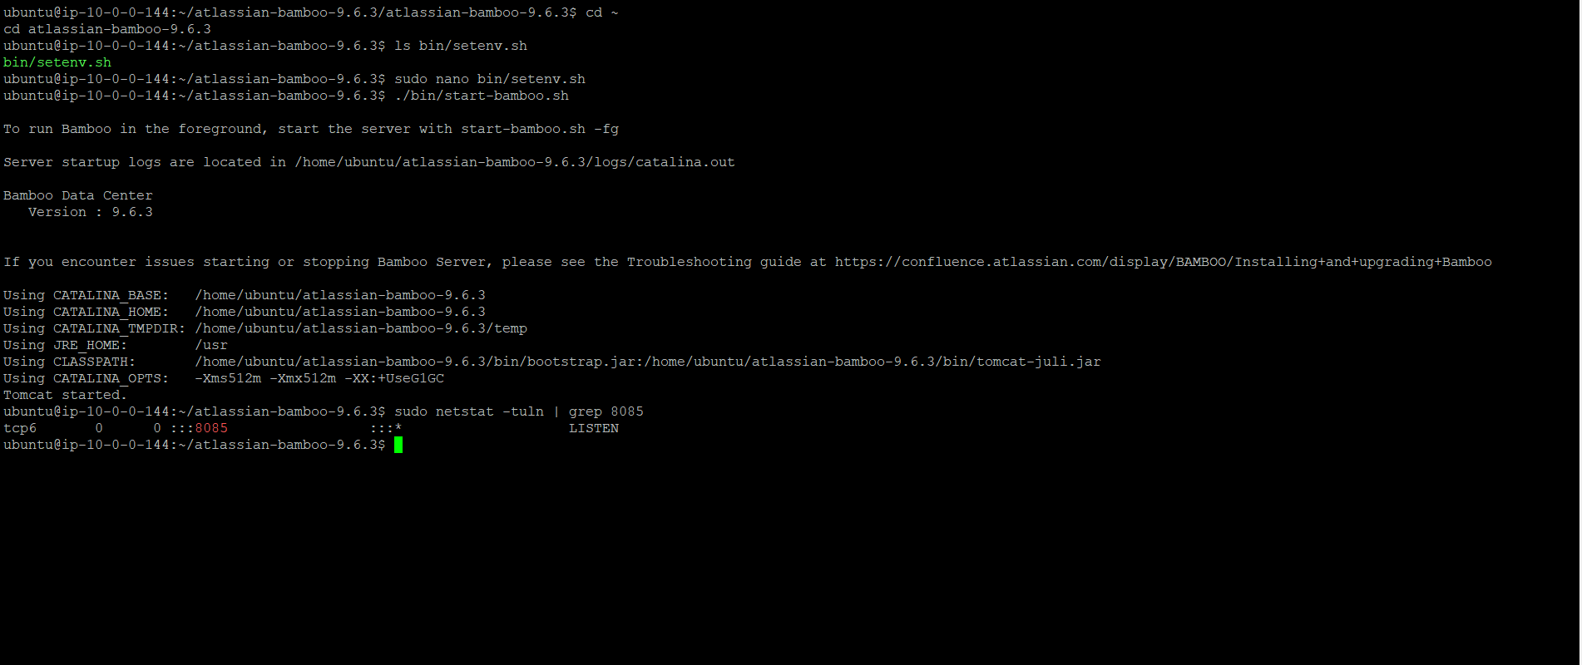
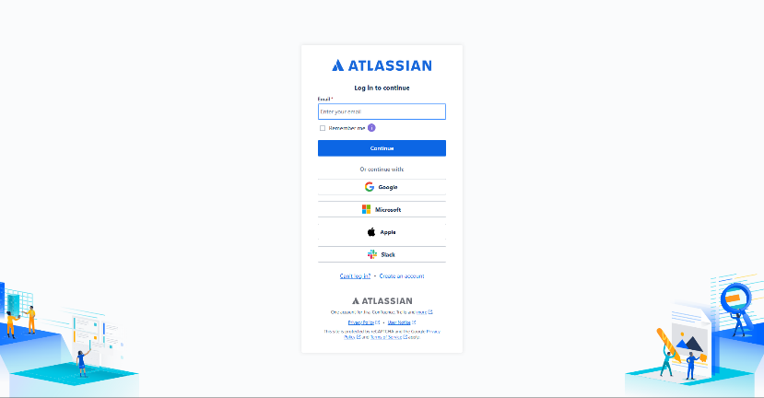
Choose License Type:
we must select Trial License → paste trial key → continue.
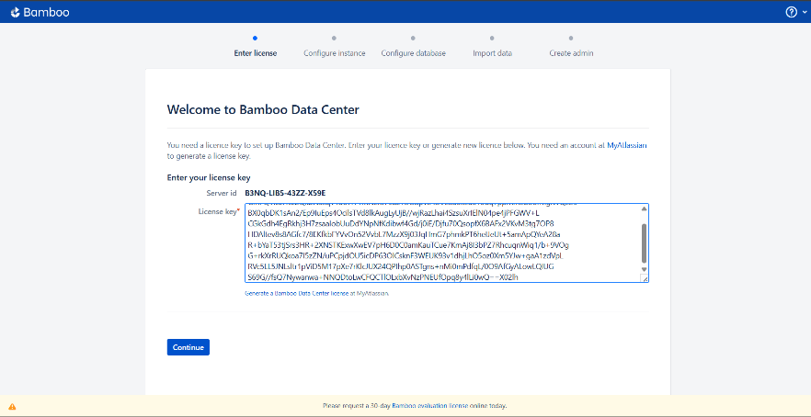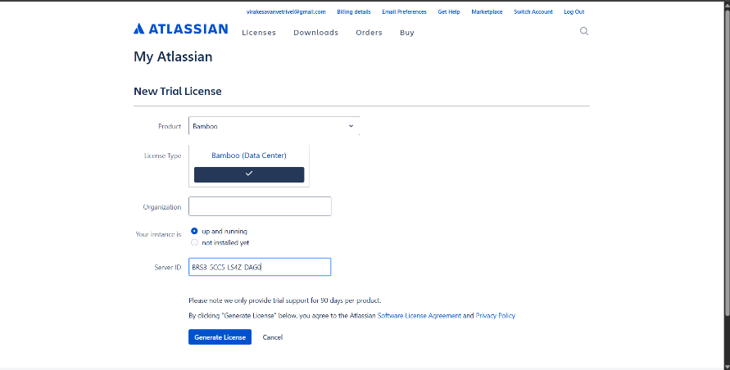
Configure Bamboo Instance
we will see these screens:
Configure Bamboo Home Directory
Choose built-in database (or external DB)
Start system setup
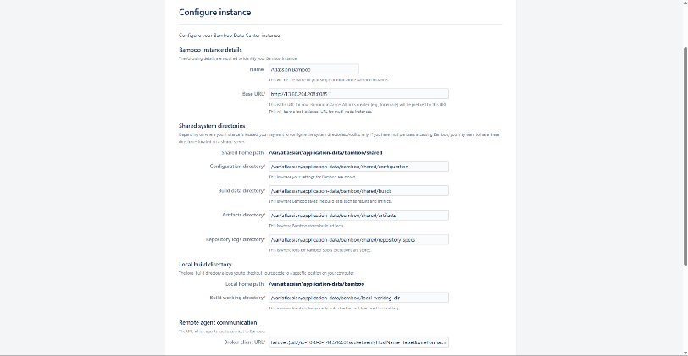

Create Admin Account
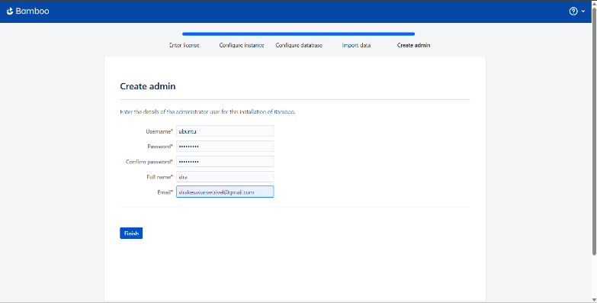

Bamboo Administration Dashboard Opens
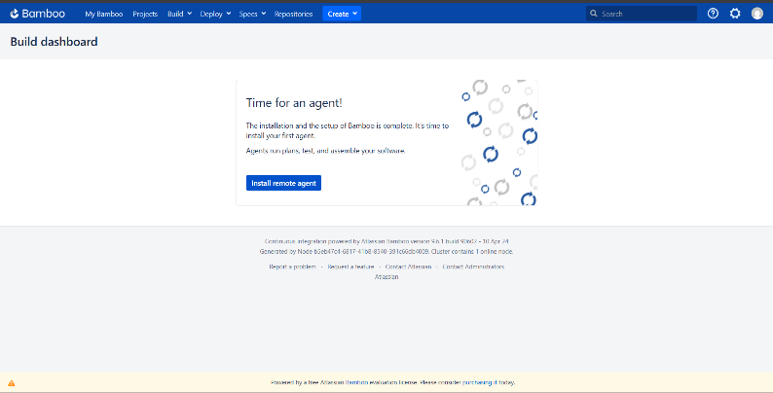

Server Capabilities
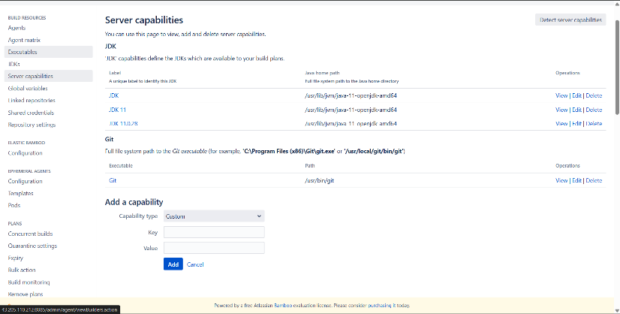
Create Tasks: Build & Run
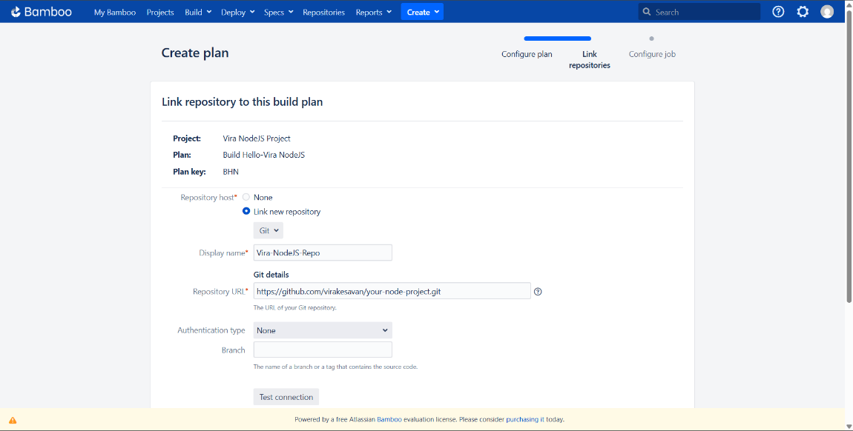
Bamboo Plan Creation
A Bamboo Plan defines how the CI/CD pipeline runs — from pulling code to building and deploying the application.
Steps:
Go to Bamboo Dashboard
Click Create → Create Plan

Linking GitHub with Bamboo
This step ensures Bamboo automatically pulls code when updates are pushed.
Steps:
Open the created Plan
Go to Repositories
Select Git Repository
Add:
Username → virakesavan
PAT Token → (your GitHub personal access token)
Enable Polling
Enable Trigger on repository push
Now Bamboo will automatically check your GitHub repo and run the pipeline when changes occur.
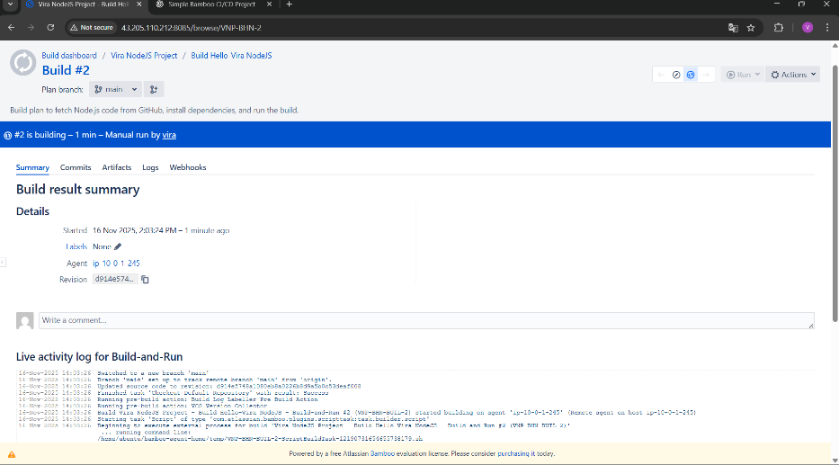

Bamboo Pipeline Stages
Bamboo pipeline includes Stages → Jobs → Tasks.
Create Stage – “Build Stage”
This stage prepares your application.
Add Jobs:
Job Name: build-job
Tasks:
Checkout source code
Install dependencies
For Node.js: npm install
Build Docker image:
docker build -t hello-vira-nodejs .
Create Stage – “Deployment Stage”
This stage handles production deployment.
Add Jobs:
Job Name: deploy-job
Tasks:
Login to DockerHub:
docker login -u virakesavanvetrivel -p ********
Push Docker image:
docker push virakesavanvetrivel/hello-vira-nodejs
Run Docker container on EC2:
docker run -d -p 80:3000 hello-vira-nodejs
Connecting DockerHub With Bamboo
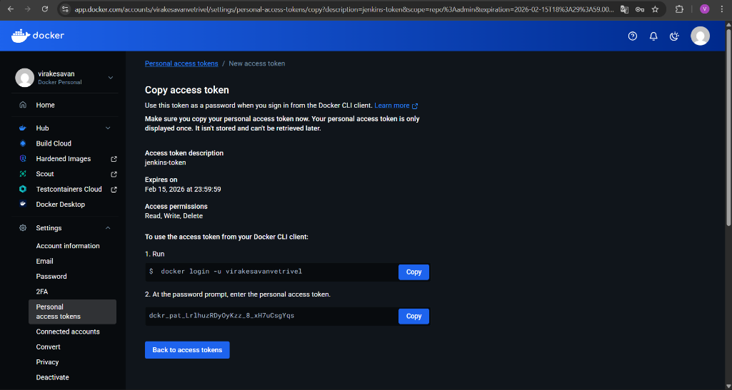
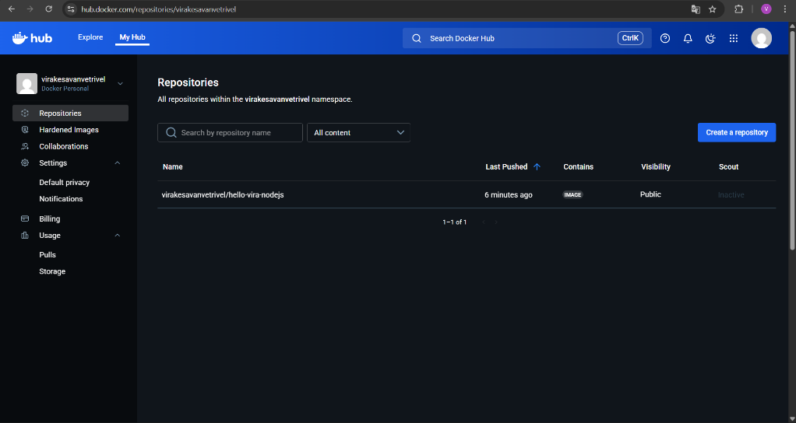

Steps:
Go to Bamboo → Administration
Select Security → Credentials
Add DockerHub credentials:
Username: virakesavanvetrivel
Password: *********
Save
This allows Bamboo to push built images directly to DockerHub.
Pipeline Execution Flow
Once everything is connected, the flow works like this:
Developer pushes code to GitHub
Bamboo detects the change
Bamboo triggers the Build Stage
Pulls code
Installs dependencies
Builds Docker image
Bamboo triggers the Deployment Stage
Logs in to DockerHub
Pushes Docker image
Runs container on EC2
Application becomes live on the EC2 public IP 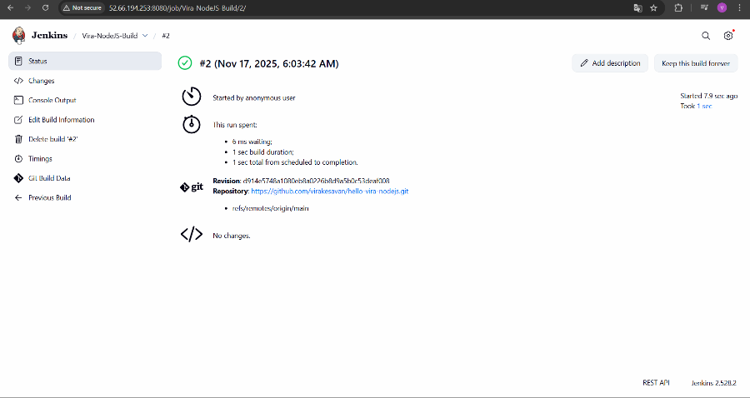
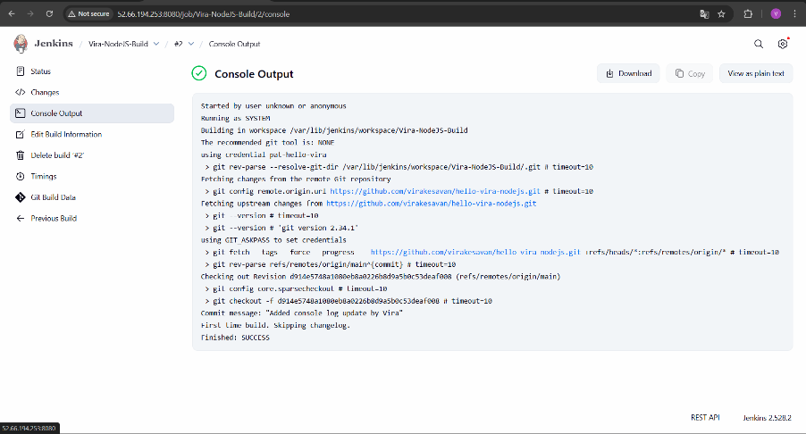

Final Pipeline Execution
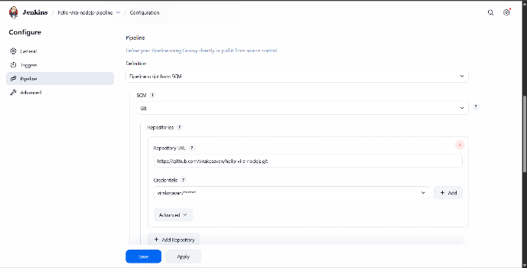
Developer Pushes Code to GitHub
Repository:
➡️ https://github.com/virakesavan/hello-vira-nodejs
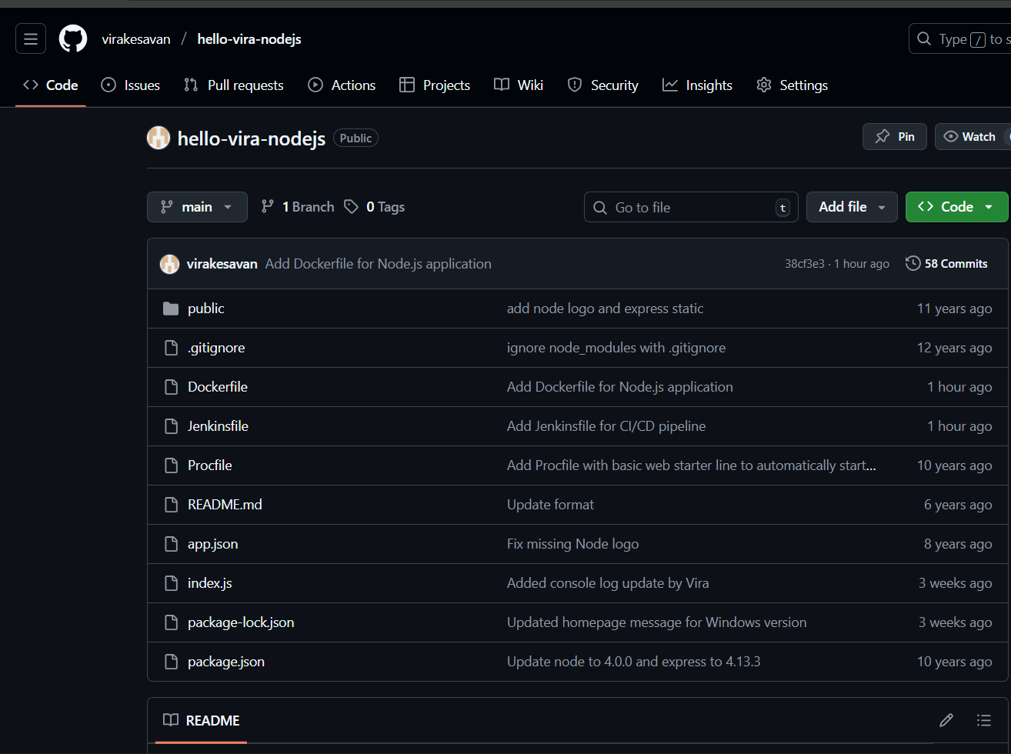
Action:
git add .
git commit -m "final update"
git push origin main
Bamboo Detects Code Change & Triggers Pipeline
In Bamboo dashboard → The Plan starts automatically.
Stages executed:
Source Code Checkout
Bamboo pulls latest code from GitHub (your repository).
Jenkins Build Trigger
Bamboo triggers Jenkins using the Jenkins integration plugin.
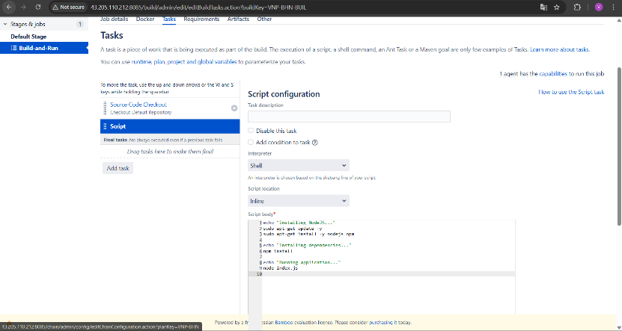
Jenkins Build Execution
Clone GitHub Repo
git clone https://github.com/virakesavan/hello-vira-nodejs.git
Install Node Modules
npm install
Build Docker Image
docker build -t virakesavanvetrivel/hello-vira-nodejs:latest .
Login to DockerHub
docker login -u "virakesavanvetrivel" -p "******"
Push Image to DockerHub
docker push virakesavanvetrivel/hello-vira-nodejs:latest
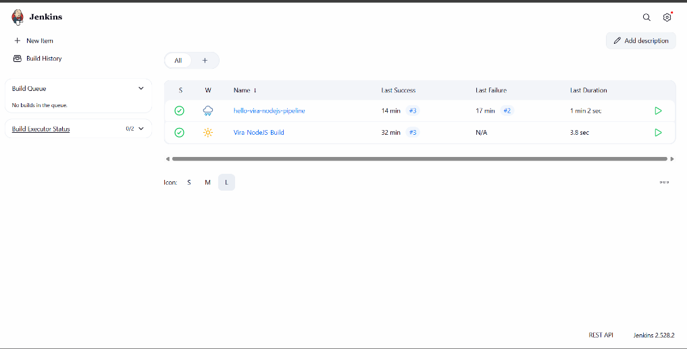
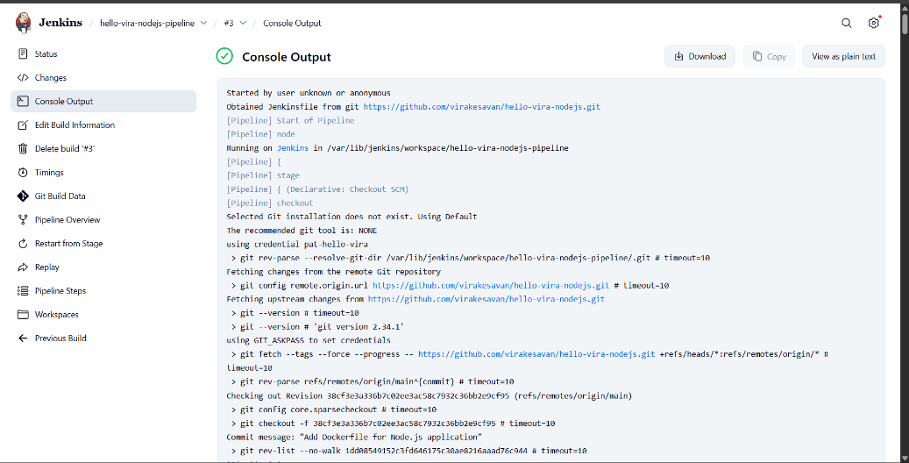

Once Docker push is completed, Jenkins returns SUCCESS to Bamboo.
Bamboo Deployment Step
A second Bamboo Task:
Pulls Docker image from DockerHub on EC2
Runs the container
Commands:
docker pull virakesavanvetrivel/hello-vira-nodejs:latest
docker stop nodeapp || true
docker rm nodeapp || true
docker run -d -p 3000:3000 --name nodeapp virakesavanvetrivel/hello-vira-nodejs:latest
Application Running on EC2
Open browser:
http://52.66.194.253:3000
You should see:
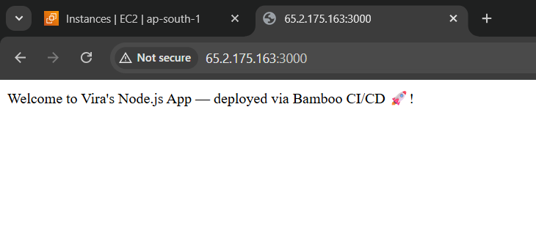
Final Output Verification:
Docker Container Running
docker ps
Output:
